Follow this example to export your postgres DB into a .sql file

- If you’re working in your postgres shell

Type the command psql <databasename> <username>

Type your password for your user

Work in your database, do all the assignments. When you’re sure that you have all the information in the database exit the postgres shell.

On your command line, OUTSIDE the postgres shell, type the following command

pg_dump -U username dbname > filename.sql

It should prompt you to enter your password and it should create a filename.sql in the directory you’re working.

That file, if you open it on Visual Studio, should look like this:

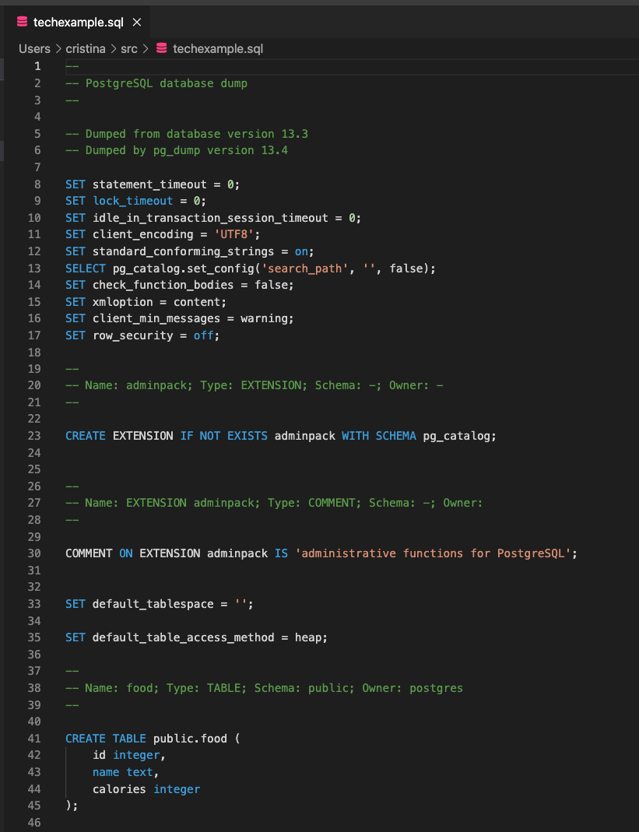

That is the file that you should submit in your assignments folder in Github. Please, put that file in a new directory (could be SQL practice) and submit it as a PR request.

- If you use PG admin please follow these instructions: https://www.a2hosting.com/kb/developer-corner/postgresql/import-and-export-a-postgresql-database#:~:text=In%20the%20left%20pane%20of,Format%20list%20box%2C%20select%20SQL.

